PRESS RELEASE

COMMUNICATIONS AND MEDIA TEAM OF THE 43RD ASEAN SUMMIT 2023

No.18/SP/TKM-ASEAN2023/EN/8/2023

PLN Guarantees Flicker-Free Electricity Services at 43rd ASEAN Summit

Jakarta, 31 August 2023 – State-run Electricity Company PT PLN (Ltd.) guarantees the availability and supply of power during the 43rd ASEAN Summit, which will take place in Jakarta on 5-7 September 2023.

To emphasize this readiness, PLN held an power alert call on Thursday (31 August) at Istora Senayan, Jakarta. In support the successful organisation and smooth running of the 43rd ASEAN Summit, PLN is ready to supply flicker-free power and deploys hundreds of personnel.

"Next week, the ASEAN Summit will take place. Our duty is to maintain the power security and resilience of the ASEAN Summit's. For this reason, we ensure all personnel are ready to support," said PLN President Director Darmawan Prasodjo, Thursday (31 August).

Darmawan further explained that the PLN team is more capable with experiences in various events, such as the G20, Christmas and New Year Celebrations, Idul Fitri, and the ASEAN Summit in Labuan Bajo. In addition, Darmawan added that PLN now has more solid and responsive working procedures and decision-making.

"Usually, it takes months of preparation for an event like this. However, with our experience, the preparation for this ASEAN Summit is done in less than a month. We are imposing an electricity standby period from 25 August to September 2023 by preparing electricity generation, transmission, distribution systems, and all personnel to succeed the Summit," emphasized Darmawan.

The operational day of the generator (HOP) that supplies the Jakarta electricity system is currently over 15 days. With a total of 13 substations, the backbone of the transmission network, are also in a prime position and without interference.

"PLN also implements an anti-blackout protocol by implementing a responsive load control system by automatically changing from one system to another. So, the entire network system is in a secure position," he said.

PLN prepared four layers of supply schemes for six main venue locations and two airports and two layers for 19 hotels where delegates of the ASEAN Summit are staying. PLN is also preparing supporting equipment in the form of 11 Mobile Substation Units with a total capacity of 7,940 kVA and 9 Uninterruptible Power Supply (UPS) with a total capacity of 2,980 kVA, as well as building the KTT ASEAN Electricity Control Center as an electricity command center.

"We have deployed 955 personnel who are ready to carry out electricity security, move quickly to fulfill customer service, and ready to serve at the SPKLU for 24 hours," he said.

Apart from the electricity system, PLN is preparing a complete electric vehicle charging infrastructure. PLN has prepared 79 EV charging stations, namely 74 Public Electric Vehicle Charging Stations (SPKLU) and five Public Electric Charging Stations (SPLU) for the 560 electric cars and 240 electric motorbikes used during the 43rd ASEAN Summit.

Moreover, dozens of elite electrician officers (PDKB) are on standby to secure the electricity supply for the 43rd ASEAN Summit. These officers are on 24-hour standby during the event.

Darmawan emphasized that PLN will always provide the best operational performance to support all international events in Indonesia. PLN is also ready to be at the forefront to oversee the success of every event and maintain Indonesia's face in the eyes of the world.

“This ASEAN Summit will be the face of Indonesia in the eyes of the world. PLN is ready to go all out to make this international event a success by providing electricity service without zero downtime," he said. (Eko Budiono/Alex Madji/Elvira Inda Sari/PR)

***

For more information, please contact:

Director General of Public Information and Communications of the Ministry of Communications and Informatics – Usman Kansong (0816785320).

Get more information at http://asean2023.id, https://infopublik.id/kategori/asean-2023, and https://indonesia.go.id/kategori/ragam-asean-2023

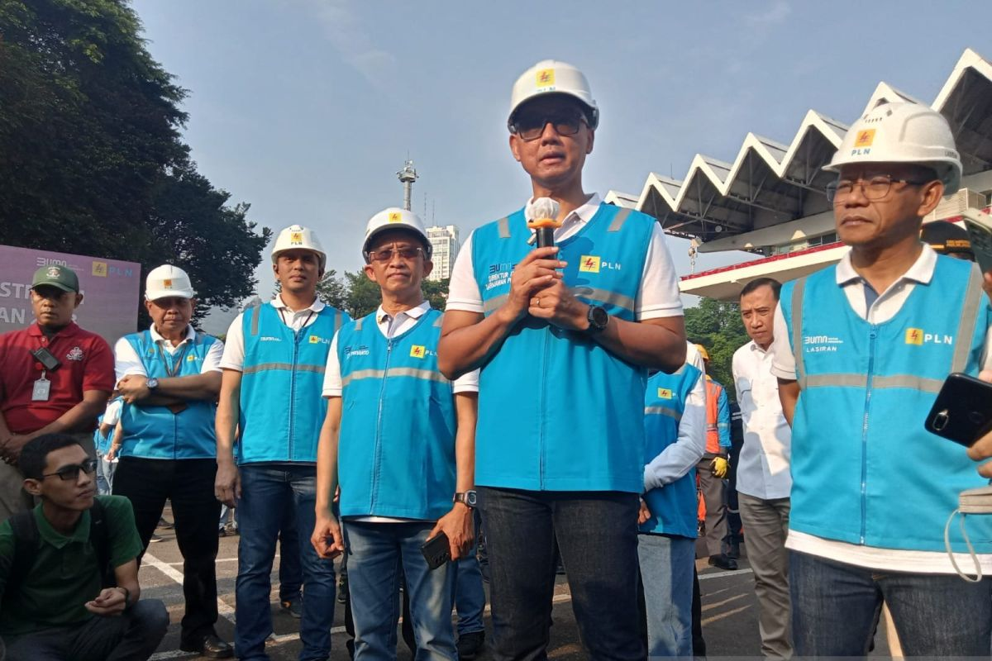

President Director of PT PLN (Ltd.) Darmawan Prasodjo (second from right) at the ASEAN Summit Electrical Inspection at Istora Senayan, Central Jakarta on Thursday (31 August). (ANTARA/Farhan Arda Nugraha)

